ECE282 Lab 4

Austin Sypolt

What do the following commands do?

1. Date

Gives the current date and time according to the system

1. Touch

Allows for a user to create, change, and modify timestamps of a file. Touch -filename- allows for the creation of a new file under the given filename.

1. Wc

Prints the number of lines, number of words, and then the number of bytes in a given filename.

1. What is the meaning of each output of the command ‘wc’?

Wc -filename-

*number of lines* *numbers of words* *number of bytes* -filename-

Write down the commands that can do the following tasks:

1. Find out how many lines are there in the output of ‘man –k read’
2. Find out how many words are there in the file ‘dirent.h’ (File is located at /usr/include/dirent.h)

1603

1. Change the mode (the permission of a file)

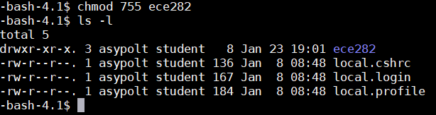

2. Make File

3. Play with masking

a) In a **struct stat**, the variable that contains the file size is **st_size**. What is the variable that contains the file permission (protection)?

St_mode

b) What is the POSIX macro to check if a file is a directory?

S_IDIR

1. The flag defined for the **st_mode** field for a ‘**directory**’ is S_IFDIR. What is its bitmask value?

00007

In Binary: 0000000000000111

In Octal: 00007

1. What is the bit mask to check for “owner has read permission”?

Chmod *** where the first * is owner, giving the rwx (read/write/execute) permissions of the given group. For the owner to have read permissions the first * must be at least 4. Ex. Chmod 400, 500, 600, 700, all give the owner read permissions.

1. What is the bit mask to check if a file has all the following permissions

*Owner can read, write; group can read only; others cannot read/write/execute*

Owner can read: 6 (110)[rwx]

Group can read only: 4 (100)

Others cannot read/write/execute: 0 (000)

Chmod 640 -filename-

Chmod (“filelocation”, 640);

Why do software engineers prefer using macro and flag instead of the octal bit mask directly?

By using macro and flag it is much easier for software engineers to repeatedly call these processes. By using the octal bit mask directly there would be a lot more unnecessary randomness to remember as well as confusion when it comes to getting new users from a different system used to it. The macros and flags just make things much easier in essence because of the preset calling that is done.